**NM2207 INTERMEDIATE PROJECT SUBMISSION FOR WEEK 9**

**Some details about the project (questions from Week 10):**

***What is your project about?***

Rising prices of BTO flats in Singapore in non-mature estates.

***What is the data you plan to use?***

<https://data.gov.sg/dataset/price-range-of-hdb-flats-offered>

This data set shows the price range of BTO flats offered in non-mature estates each year from 2008 to 2021.

***What is the question you plan to answer?***

Will BTOs still be affordable in 5 years’ time?

***Why is this an important question?***

As BTOs are usually applied for by university undergrads due to the grants available to those with no / lower income levels, it is a cause of concern for me as I would like to still be able to comfortably afford public housing, and I’m sure other potential house owners share the same sentiments as well. According to the thread of a post titled “BTO flats are priced such that they remain affordable for buyers, says HDB, which gives the breakdown…” on r/singapore, users are in disbelief over the title, which is an actual statement made by HDB. At the rate BTO cost prices are increasing now, who knows how much more expensive they will be in 5 years’ time and whether the promise of public housing being affordable will be upheld.

I aim to provide an illustration of the pricing trends of the prices of flats in non-mature estates as I believe high prices in the mature estates are rather justifiable due to their prime location and accessibility. Public housing should be made affordable to the common Singaporean and should not be a tool for profit-making when there are citizens struggling to even put a roof over their heads. Therefore, I am passionate to illustrate the change in prices since 5 years ago and explore if there are estimations for the prices 5 years from now, while documenting the reasons behind previous and potential rise (or falls) in BTO prices. For the purposes of this project, I will be focusing on 4-room flats those are the most popular BTO option, according to mynicehome by HDB. I will also be using the median max selling price of the available data as the varying number of BTO launches in every Financial Year will skew the data’s average.

***Which rows and columns of the dataset do you plan to use, to answer this question?***

Columns: Financial Year, Town, Room Type, and Max Selling Price.

Rows:

1. FY from 2008 to 2021
2. Every town
3. Only 4-room Room Types
4. The corresponding max selling price of every available data according to rows a to c.

**Describing the data of the project (questions from Week 11):**

***Describe the data of your project and the visualizations you plan to use.***

The data shows that the latest prices are definitely higher than those in 2008 but there was no constant year-on-year increase. Instead, there were periods of inclines and declines probably due to external factors such as a bearish housing and economic market, and the covid pandemic.

I plan to utilise bar graphs to illustrate the rise in prices as it provides an clearer depiction of how gradual or steep the rise is. I also plan to use a line graph to document the average rise in income as the most common argument is that the rate in which income rises is not relative to the rate at which public housing (among other things) is rising at. The idea of using two different types of graphs is so that the webpage does not appear dull and repetitive.

***Attribute anything you plan to use from somewhere else.***

Code structures were taken from w3schools and previous assignments throughout the semester.

***Report the errors and challenges you are facing.***

* Had issues cleaning up the aesthetics of the webpage using html and CSS as I had originally added aesthetics in html one by one.
* Could not get the sidebar to work at first.

**Storyboard of the project (questions from Week 12):**

***Write the storyboard for the data story.***

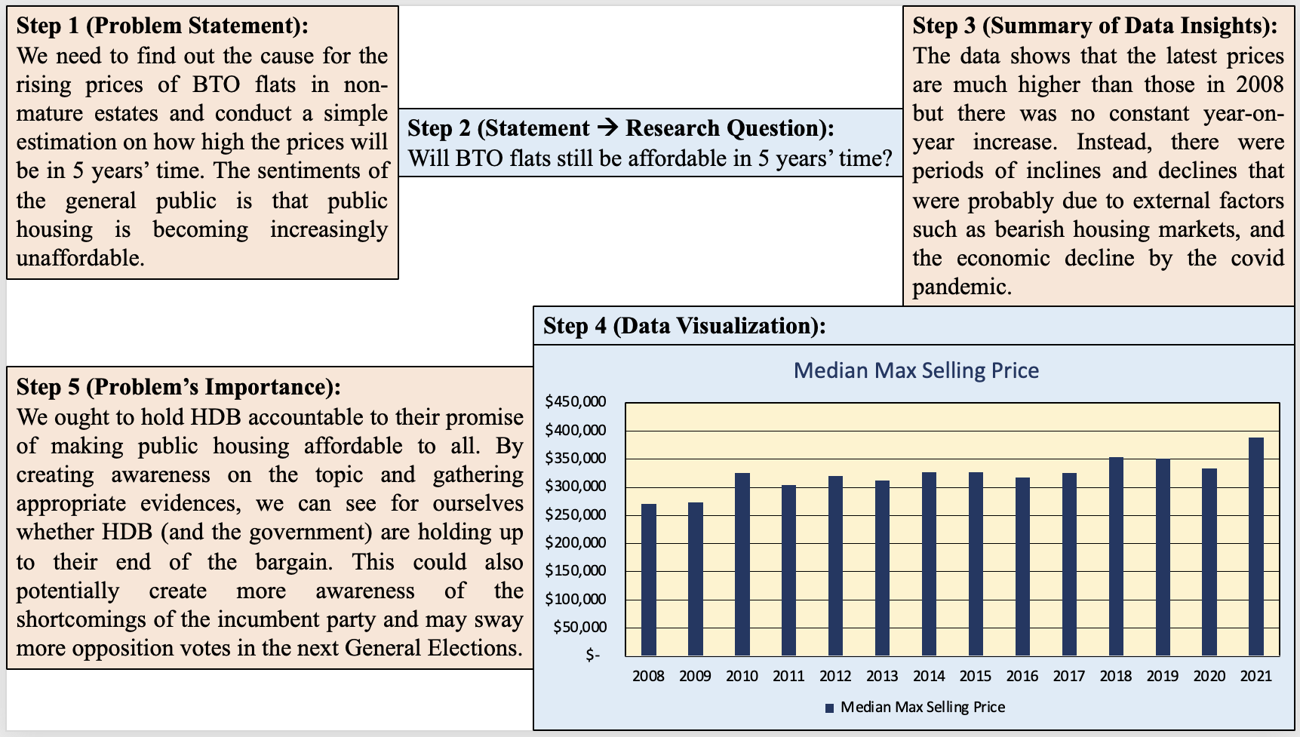

***Report the errors and challenges you are facing.***

Nil.

**Concepts (from week 2-8) to be used in final code:**

|  |  |  |  |  |
| --- | --- | --- | --- | --- |
| ***Week*** | ***Concept*** | ***How I've used it*** | ***Line number*** | ***Filename*** |
| 1 | Body Paragraph and Headers | Basic structure of the webpage. | From 10 | index.HTML |
| 2 | Image Sourcing and Tooltip | To insert an image that relates to my topic under my header and include a tooltip. | 16 | index.HTML |
| 2 | Link Sourcing | Insert hyperlink of a news article that is directly related to my topic. | 28 | index.HTML |
| 3 | Designing of Webpage with CSS | Link appstyle.css file to webpage  Changed font type, size and colour | 4 – 8  From 1 | index.HTML  appstyle.css |
| 4 | Form Making | Allows readers to input their annual income and the output shows the percentage to be used for house loan repayment | 46-51  From 1 | index.HTML  main.js |
| 5 | Sidebar | Include a short “about the writer” section to let readers know more about the article’s author | 14 – 25 | index.HTML |
| 7 | Charts: Bar and Line Graphs | Illustrated the price trends of my topic as well as the annual income levels for comparison. | 33 and 42 | index.HTML  main.js |

***Updated GitHub with rough structure and placeholders to various components:***

Can be found in the HTML file that was uploaded together in the folder with this document.